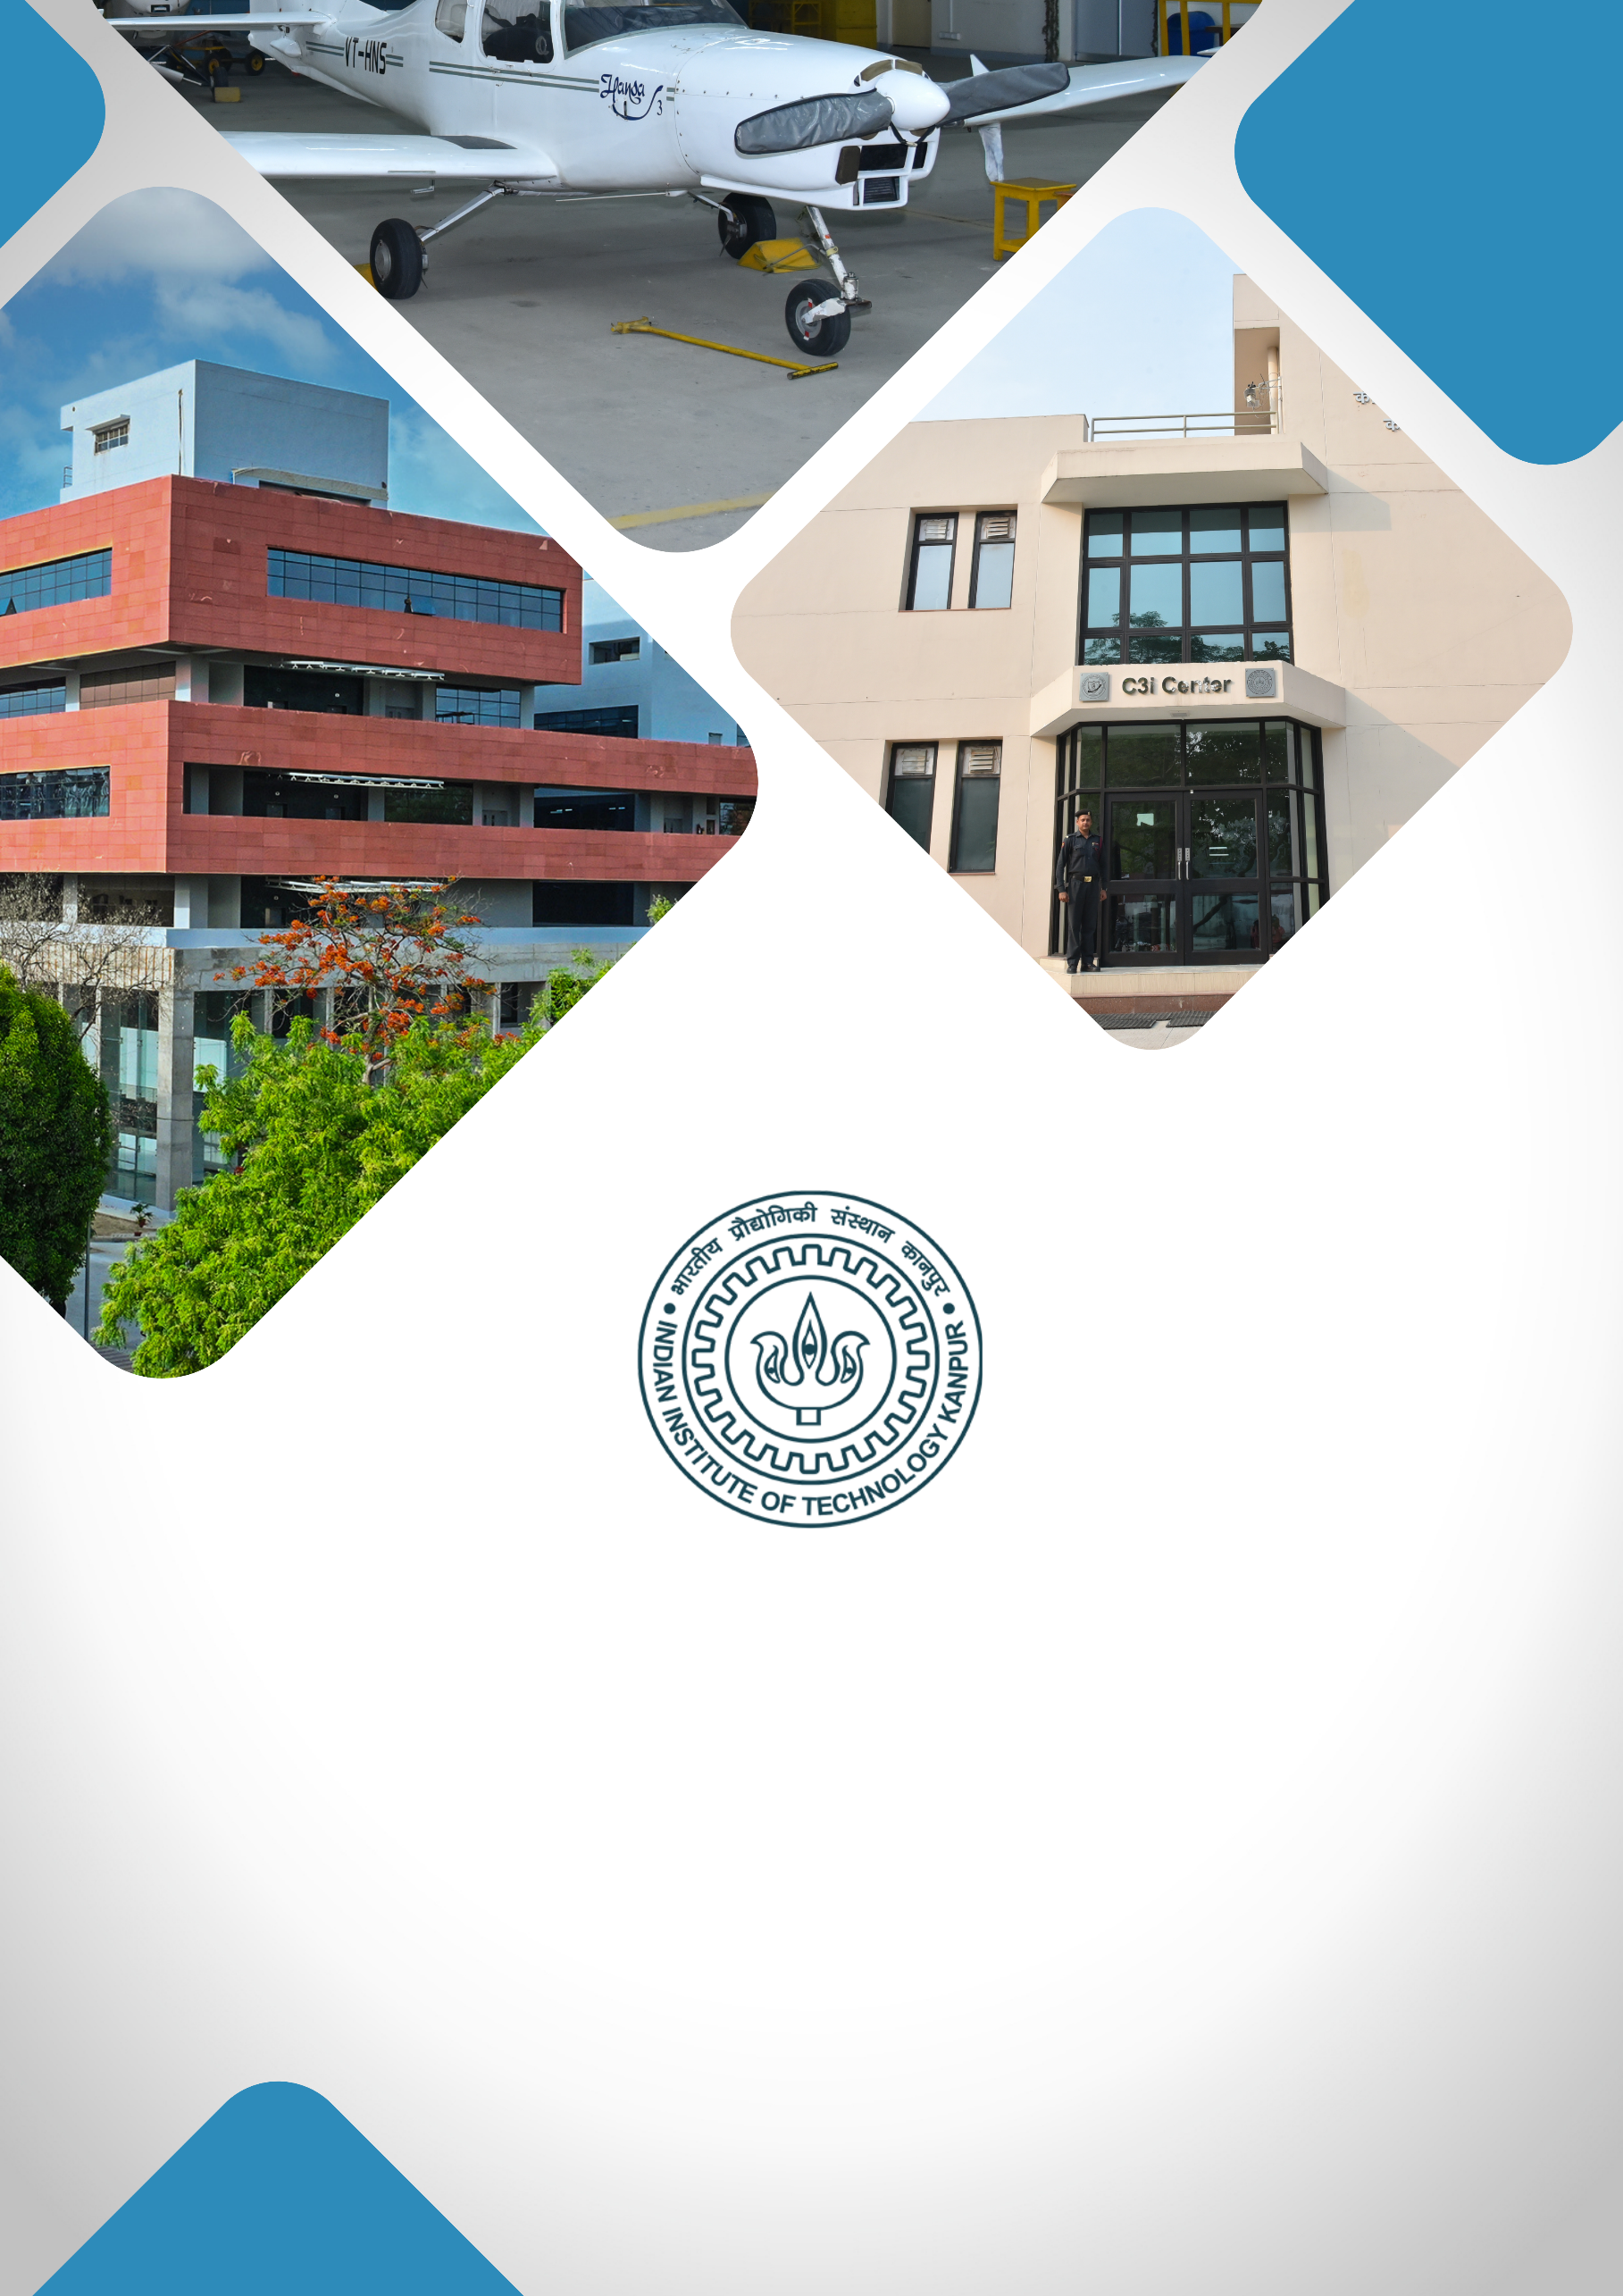

**Medical Devices and Diagnostics Prototyping And Testing Facility**

**TABLE OF CONTENTS**

1. **About IIT Kanpur**
2. **Institutional Vision**
3. **Project Title**
4. **Executive Summary**
5. **Background & Rationale / Motivation**
6. **Project Objectives**
7. **Expected Outcomes**
8. **Expected Impact**
9. **Milestones & Implementation Timeline**
10. **Financial Budget**
11. **Team Involved / Key Faculty Members**

**ABOUT IIT KANPUR**

**Indian Institute of Technology Kanpur**, established in 1959, is one of the premier institutions established by the Government of India. The aim of the Institute is to provide meaningful education, conduct original research of the highest standard, and provide leadership in technological innovation. The Institute has gained a legendary reputation in the country through its academic, social, and economic contributions. The combined record of its past and present faculty and students along with the alumni spread across the world is awe-inspiring.

From the start, the students have been provided education with a strong emphasis on the fundamentals of science and engineering and their application in the field of study. Subsequently, programs in humanities, management, and several interdisciplinary programs like design, environmental engineering and management, material sciences, nuclear engineering and technology, and photonic sciences and engineering programs were started. The education imparted to the students has stood by them even as they acquired new skills and knowledge during their professional careers.

IIT Kanpur continues to be a much sought-after destination for UG and PG studies. In the 65 years of its existence, over 43,000 students have graduated from the Institute. The alumni of IIT Kanpur have made their alma mater proud through their achievements and contributions in diverse fields like engineering, academia, business, entrepreneurship, and public service.

The Institute today has close to 600 full-time faculty members and all of them have earned their degrees from the top universities in the world. The Institute faculty members have often been bestowed with prestigious national honours as listed below:

|  |
| --- |
| Padma Shri |
| Infosys Prize (Infosys Science Foundation) |
| J C Bose Fellowship |
| Shanti Swarup Bhatnagar Prize for Science & Technology |
| Fellow, Indian National Science Academy (INSA), New Delhi |
| Fellow, Indian Academy of Sciences (IAS), Bangalore |
| Fellow, Indian National Academy of Engineering (INAE), New Delhi |
| Fellow, The National Academy of Sciences, India (NASI), Allahabad |
| Fellow, The World Academy of Sciences (TWAS), Italy |
| Humboldt Research Award |
| TWAS Prize |
| Wellcome Trust/India Alliance Early Career/Intermediate/Senior Fellowship |
| Tata Innovation Fellowship |

The Institute has a large pool of academic resources spanning 19 departments, 25 centers, and 3 Interdisciplinary programs in all engineering, science, design, humanities, and management disciplines. It has a student strength of more than 9000 across all programs.

IIT Kanpur has always laid strong emphasis on new academic initiatives that will allow the Institute to broaden its academic repertory and create an impact in academia and society. Some of these initiatives include the Department of Sustainable Energy Engineering and the Department of Cognitive Science which were established in the year 2020.

**INSTITUTIONAL VISION**

***"To create, disseminate, and translate knowledge in science, engineering, and allied disciplines that will best serve society."***

1. **Developing Technologies that Solve Real-World Problems:** Prioritising research and development that address critical societal challenges, translating innovations into solutions with high-TRL (Technology Readiness Level) technologies. The goal is to establish an Office of Translational Research within the Directorate for strategic guidance, funding support, industry connections, and information on government and industry needs.

**Major focus areas:**

* **Large-Scale AI Deployment**: Implementing AI solutions on a wide scale, focusing on impactful applications for government and industry sectors, including public grievance redressal and fraud detection.
* **MedTech:** Making healthcare accessible and affordable through cutting-edge research, device innovation, and medical training with the **Mehta Family Center**, **MedTech IITK**, and the **Gangwal School of Medical Sciences & Technology**.
* **Cybersecurity:** With **C3iHub**, focused on developing advanced solutions, supporting startups, and offering specialised training for critical cybersecurity needs.
* **Unmanned Aerial Vehicle (UAV) Technology**: Advancing UAV technology with a focus on defence, humanitarian, and disaster relief applications, and providing affordable testing facilities to promote industry growth.
* **Sustainability:** Positioning IIT Kanpur as a leader in sustainable development through technologies and initiatives led by the **Kotak School of Sustainability**, the **Chandrakanta Kesavan Centre** **for Energy Policy and Climate Solutions**, and the **Department of Sustainable Energy Engineering**.

1. **Elevating R&D Excellence:** Focus on recruiting top talent, creating state-of-the-art facilities, securing substantial research grants, and maintaining a balance between research quality and quantity.
2. **Enhancing Teaching Quality:** Achieving leadership inhigh-quality education by establishing a Centre for Teaching Excellence, developing courses in soft skills and technical writing, and introducing faculty career paths that focus on research, translational projects, or teaching.
3. **Enhancing Student Life and Campus Infrastructure:** Upgrading existing hostels and constructing new ones to accommodate growing student numbers. Developing state-of-the-art infrastructure within the campus.

**PROJECT TITLE**

**Medical Devices and Diagnostics Prototyping and Testing Facility**

**EXECUTIVE SUMMARY**

India's medical devices market, currently valued at $11 billion, is projected to grow to $50 billion by 2025, driven by increasing healthcare demand, a growing middle class, and advancements in healthcare infrastructure. Key opportunities lie in segments such as diagnostic imaging, patient aids, and orthopedics. The COVID-19 pandemic has further accelerated growth in device production, including ventilators and diagnostic kits. Recent developments, such as medical device parks in states like Uttar Pradesh and Tamil Nadu, alongside government initiatives like the National Medical Device Policy (2023) and the Production-Linked Incentive (PLI) scheme, aim to boost indigenous manufacturing.

However, India remains dependent on imports for 80% of its medical devices, especially high-end equipment like MRI machines and widely needed components like biochips. Challenges include limited manufacturing infrastructure, regulatory hurdles, and a deficit in high-tech and high throughput production capabilities. IIT Kanpur is uniquely positioned to address these gaps through its engineering and biomedical expertise by fostering translational research, developing specialized talent, and contributing to policy reform.

In this regard, establishing a prototyping and testing facility at IIT Kanpur would accelerate the development of market-ready devices by providing cutting-edge infrastructure, supporting startups, and fostering interdisciplinary innovation. The facility would also address regulatory and certification barriers, facilitating smoother transitions from lab to market. By becoming a hub for indigenous medical device innovation, IIT Kanpur could reduce India’s dependence on imports and drive transformative healthcare advancements.

**BACKGROUND**

The establishment of the Medical Devices and Diagnostics Prototyping and Testing Facility at IIT Kanpur could be a visionary response to address pressing gaps in India's rapidly expanding medical devices sector. Valued at $11 billion, the Indian medical devices market is poised to quintuple to $50 billion by 2025, driven by rising healthcare demands, an expanding middle class, and substantial advancements in healthcare infrastructure. Segments such as diagnostic imaging, point-of-care diagnostics, patient aids, medical implants, and orthopedic devices are ripe for growth. The COVID-19 pandemic further underscored the critical need for domestic manufacturing, spurring production in ventilators, diagnostic kits, and personal protective equipment. Despite these opportunities, India remains heavily reliant on imports, sourcing nearly 80% of its medical devices, particularly high-end equipment and widely used components such as MRI machines, cancer diagnostics tools, biochips, etc. This reliance highlights the urgent need for indigenous innovation and advanced infrastructure.

**RATIONALE**

India faces significant challenges in the medical devices sector, despite supportive government initiatives like the National Medical Device Policy (2023) and the Production-Linked Incentive (PLI) scheme. The country’s manufacturing capabilities are concentrated in low- to mid-tech devices, leaving a void in high-tech production. Translating laboratory research into commercially viable products is generally hindered by insufficient prototyping and testing facilities, regulatory complexities, and weak intellectual property protections. Furthermore, limited infrastructure for certification and compliance hampers the market-readiness of innovations. These barriers deter investment, stifle innovation, and perpetuate India's dependence on imported medical devices. Addressing these challenges requires a comprehensive approach that combines cutting-edge infrastructure, interdisciplinary expertise, and robust industry-academia collaborations.

**PROJECT VERTICALS**

The proposed facility aims to bridge critical gaps in the medical devices innovation pipeline by leveraging IIT Kanpur's strengths in engineering and biomedical research. The objectives include accelerating the development, prototyping, and validation of medical devices, ensuring smoother transitions from research to commercialization. By fostering interdisciplinary collaboration across engineering, materials science, and healthcare domains, the facility seeks to generate innovative solutions tailored to India's healthcare challenges. It will also create specialized training programs to cultivate a skilled workforce adept at medical device design, fabrication, and regulatory compliance. Additionally, the facility will provide start-ups with access to advanced equipment, mentorship, and resources, while addressing certification and regulatory hurdles to streamline product development.

**Facility Vertical 1: Electro-Mechanical Devices (INR 5 Cr.)**

The Electro-Mechanical Devices vertical will focus on the design and testing of advanced devices like left ventricular assist devices (LVAD), artificial limbs, robotic exoskeletons, diagnostic imaging systems, ventilators, and patient monitoring equipment. Featuring state-of-the-art tools such as real-time simulation hardware (e.g., Speedgoat and National Instruments systems), this vertical will enable precise evaluation of device functionality under simulated real-world conditions. Testing tools like the Flying Probe Tester, ESD Generator, and Electrical Fast Transient Generator will ensure compliance with stringent performance and safety standards. High-resolution diagnostic tools, including spectrum analyzers, oscilloscopes, and thermal imaging cameras, will enable comprehensive assessments of electrical, thermal, and mechanical performance. By supporting the development of reliable and robust devices, this vertical forms the cornerstone for indigenous manufacturing of high-quality medical equipment.

**Facility Vertical 2: Neural Engineering Devices (INR 4 Cr.)**

The Neural Engineering vertical will support the development of cutting-edge neural interfaces such as microwires, electrodes, ECoG arrays, and nerve cuffs. Equipped with tools like electrophysiology recording systems, electrochemical impedance spectroscopy setups, and cyclic voltammetry systems, this vertical will enable precise testing and optimization of neural devices. Fabrication tools like diode laser cutters, electrode sputtering systems, and advanced hot plates will facilitate the creation of custom neural interfaces. This vertical is crucial for advancing neuroprosthetics, brain-machine interfaces, and neural stimulation technologies, addressing critical needs in neurological disorders and rehabilitation. By fostering innovation in neural engineering, it will pave the way for life-changing medical advancements.

**Facility Vertical 3: In-vivo Imaging facility for preclinical testing and Validation of Medical Devices (INR 19 Cr.)**

A state-of-the-art imaging facility that houses MRI and C-Arm machines will serve as a key resource for validating the safety and functionality of implants and devices, particularly in neural and orthopedic applications. A C-Arm, also known as fluoroscopy, is a medical imaging device that provides real-time imaging of patients during surgery. These are used in various settings, including pain management facilities, outpatient surgery centers, orthopedic clinics, and more. This facility will enable in-vivo visualization, providing critical insights into device compatibility, performance, and biocompatibility. By bridging the neural engineering and biomaterials verticals, the MRI facility will ensure that prototypes meet stringent clinical requirements before entering the market. Its integration into the facility will provide a critical validation step, ensuring that innovations transition seamlessly from the lab to real-world applications.

**Facility Vertical 4: Translational Biomedical Engineering Facility (INR 5 Cr.)**

To truly realize the translational vision of IIT Kanpur we require a state of the art facility for performing clinical trials with human participants. This facility will complement the upcoming Gangwal School of Medical Sciences & Technology by allowing patients from the medical school to register and participate in ongoing clinical trials and receive novel therapies. Additionally, the translational biomedical facility will also provide access to shared facilities and resources to enable other investigators to perform their clinical research within IITK.

**Benefits of Translational Biomedical Engineering Facility:**

1. Collaborate with clinicians from the upcoming medical school.

2. Invite patients to participate in clinical trials and evaluate their progress over the long-term using wearable devices (serves as a test bed for a digital health center in future).

3. Expose BSBE/ MFCEM students (mainly PG + interested UGs) to translational research by involving them in projects that have a clinical impact.

4. Creating a mini tutorial lab space for brain-machine interfaces, electrophysiology, behavioral testing, VR/AR experiments.

5. Facilitate and encourage students to come up with their own problem statements and implement it in practice (similar to a design kitchen)

6. Cognitive testing on subjects who undergoing testing for certain new drug trials developed through drug discovery pipeline and understand side effects of drugs on cognitive abilities

**Proposed usage of facility:**

*Room 1: Approx 30 x 10 ft*

Human neurophysiology experiments using shared devices – EEG, EMG, eye trackers, joystick, central and peripheral electrical stimulation devices, brain machine interfaces

*Room 2: Approx 20 x 10 ft*

AR/VR simulation and gait analysis/ motion capture facility, space navigation

*Room 3: Approx 10 x 10 ft*

Electronics workshop for device prototyping and maintenance

Room 4: Approx 12 x 12 ft

State-of-the-art Sleep Physiology Lab: Sleep cognition and neurophysiology studies

**Facility Vertical 5: Point-of-Care Devices (INR 4 Cr.)**

The Point-of-Care (POC) Devices vertical will emphasize the development of portable and affordable diagnostic solutions for diverse healthcare settings, including rural areas. It will include generation of economical universal platforms, with multiplexing and AI/ML interventions. High-precision fabrication tools, including ultrasonic spray coaters and e-beam evaporation machines, will enable the development of advanced sensors, bio-sensors and electrodes. Laser engraving tools will support the miniaturization and customization of such POC devices. Tools like electrometers, conductivity meters, and microplate readers will support the evaluation of the base materials, generated composites and prepared diagnostic devices. These could be used for invasive, non-invasive, optical, electrochemical, chemiresistive and other types of POC diagnostic platforms such as glucose monitors, anxiety readers and pregnancy test kits, etc. This vertical will address the growing demand for accessible, scalable, and cost-effective healthcare solutions, particularly in underserved regions with minimal requirement of expertise, infrastructure and other resources at the site of the application.

**Facility Vertical 6: Biomaterials Characterization (INR 5 Cr.)**

The Biomaterials Characterization vertical will focus on analyzing and optimizing the properties of materials used in medical devices. Equipped with advanced tools like the OPTICS11LIFE PAVONE fluorescence microscopy system, this vertical will provide insights into material interactions at micro- and nanoscale levels. It will support the development of biocompatible materials for implants, coatings, and sensors, ensuring they meet rigorous safety, durability, and functionality standards. By complementing the neural engineering and POC devices verticals, this vertical will enhance the quality and performance of medical technologies developed at the facility.

**Interconnected Framework**

The verticals within the facility are designed to function synergistically, ensuring a seamless flow of innovation. For example, neural implants developed in the Neural Engineering vertical can undergo material testing in the Biomaterials Characterization vertical, be fabricated using tools from the POC Devices vertical, and validated for in-vivo performance using the MRI facility. Similarly, electro-mechanical devices can benefit from biomaterials expertise to enhance their functionality. Ultimately, many of the technologies developed in the various facilities can undergo clinical trials within the translational biomedical facility. This interconnected framework will enable the comprehensive development of innovative medical devices, ensuring faster transitions from concept to commercialization.

**PROPOSED IMPACT** (SOCIAL / SCIENTIFIC)

The facility is expected to drive the development of globally competitive medical devices, significantly reducing India's dependence on imports. It will establish a robust ecosystem for innovation, fostering entrepreneurship and creating high-quality jobs. It will also open doors to train highly skilled human resources in the field of fabrication and testing of biomedical devices. These trained individuals can be deployed across the country to establish more such centres and accelerate the progress of medical devices and diagnostic testing. Further by promoting industry-academia collaboration, the facility will ensure that cutting-edge research translates into impactful healthcare solutions. Furthermore, it will contribute to policy development, streamlining regulatory frameworks to support the growth of India’s medical devices sector.

**MILESTONES & IMPLEMENTATION TIMELINE**

|  |  |  |  |  |  |
| --- | --- | --- | --- | --- | --- |
| **DELIVERABLES/MILESTONE** | **Y1** | **Y2** | **Y3** | **Y4** | **Y5** |
| **Electro-Mechanical Devices** |  | | |  |  |
| **Neural Engineering Devices** |  | | |  |  |
| **In-vivo Imaging facility for preclinical testing and Validation of Medical Devices** |  | | | |  |
| **Translational Biomedical Engineering Facility** |  | | | | |
| **Point-of-Care Devices** |  | | |  |  |
| **Biomaterials Characterization** |  | |  |  |  |

**BUDGET**

Any other information you may like to give in support of this proposal that may help

evaluate it. (e.g.- High-resolution photographs, videos 1-2 min)

|  |  |
| --- | --- |
| **Budget Head** | **Amount in**  **(INR)** |
| Capital Expenditure (CAPEX) | |
| Civil Construction | 5 Cr. |
| Equipment & Furniture | 33 Cr. |
| Digital Infrastructure | 4 Cr. |
| TOTAL | 42 Cr. |

**TEAM INVOLVED / KEY FACULTY MEMBERS**

